Expression of Interest Form
Town & Village Renewal Scheme 2022
BUILDING ACQUISITION MEASURE

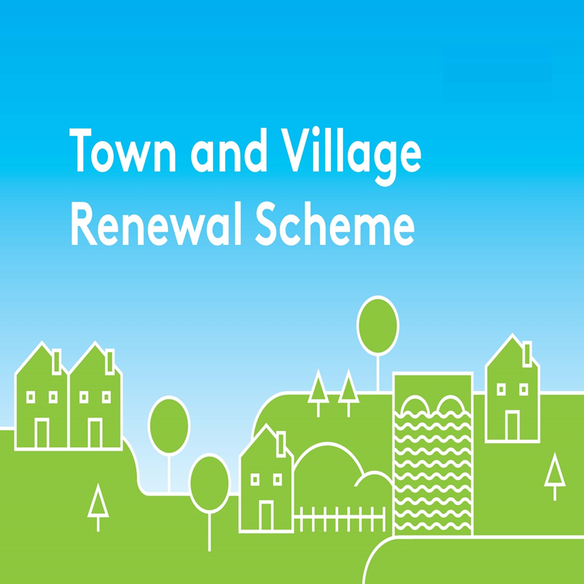
Please complete this Expression of Interest form
and return it to Donegal County Council by email to TownandVillage@donegalcoco.ie;

Town & Village Renewal Scheme 2022

Town/Village covered:

Please indicate which category of funding is being applied for:

Category 1 Category 2 Category 2B

Towns/Villages with Towns/Villages with Towns/Villages with

Population of 5,000 Population of Population up to

or less 5,001-10,000 15,000

Amount of Funding Requested:

Applicant Group:

Applicant Contact Name:

Applicant Contact Address:

Applicant Telephone Number:

Applicant Mobile Number:

Applicant Email Address:

- Please provide the Address of building (including Eircode) to be purchased and sale price. ( If there is a current for sale advertisement online please provide a link to the ad):

- Please provide a brief background to the selected building, (is it vacant and/or derelict? How long has it been vacant? Etc):

- Outline the proposed plan/use for the building?

- Has funding for this project ever been sought from other sources?
Yes No

(If "YES" yes please specify from what source and if funding was provided)

- Who are the specific project stakeholders/community partners in this project?
(Chamber of Commerce, Community group, etc.).

DECLARATION
I hereby confirm that I have read and understand this document. I request that consideration be given in support of the project as outlined above.

Signature __________________________________________________

Position __________________________________________________

Date __________________________________________________

CLOSING DATE FOR RECEIPT OF EXPRESSIONS OF INTEREST:
2pm Friday 10th June 2022
Completed forms should be returned by e-mail to TownandVillage@donegalcoco.ie before 2pm on Friday 10th June 2022.
Expressions of Interest received after the deadline will not be considered.

